Dillon Lehane
billed as "The Great Lehane" Ocean Springs, MS | +1 228 243 5647 | dillon.lehane.91@gmail.com Available on all seven seas • Happiest with a microphone in hand
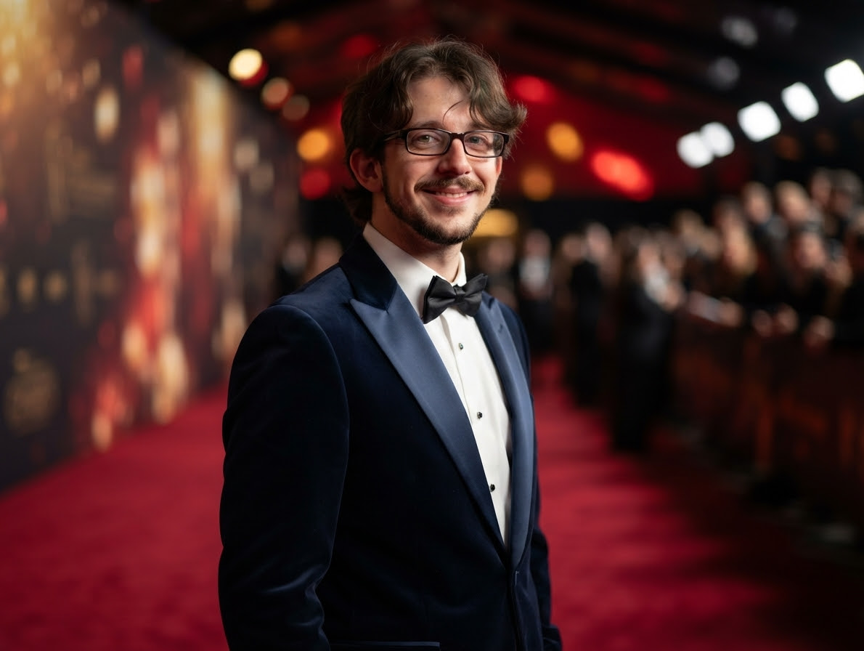

The Pitch
A born entertainer who lives for the spotlight. Nothing brings Dillon more joy than a packed lounge, a warm follow-spot, and an open mic — he adores singing for a crowd and seizes any excuse to perform. Pair that with years of close-up magic and you have a headliner who never wants the night to end.

Vocal Range & Passion for Song
- Soaring tenor to velvet baritone — thrilled to demonstrate at any hour.
- Takes requests eagerly. Encores are not requested; they are inevitable.
- Would genuinely rather be singing right now than reading this résumé.

Signature Act
- Close-up magic & sleight of hand — years of dabbling, finally weaponized for the high seas.
- "The Vanishing Volunteer" — a card trick, a story, and a table of strangers who forget they were skeptical.
- A song between every trick, because why stop performing?

Performance History (Chronological)

Headliner, 3rd Period — Substitute Teacher, Kelly Education
Ocean Springs area, January 2025 – Present
- Nightly (well, daily) sets for the single toughest crowd in show business — restless middle schoolers — held rapt through pure storytelling, including the beloved origin of the word "boycott."
- Requested back by name by half a dozen bookers (teachers) across multiple venues (schools).

Quick-Change Artist — Dollar Tree
MS, September 2024 – November 2024
- Played two management roles at once after his co-star (store manager) exited stage left. Range.

Featured Act — Student Teacher, Ocean Springs School District
Ocean Springs, MS, August 2023 – December 2023
- Held a full house of ~25 for a complete set; a visiting critic (his college supervisor) reviewed the act: "didn't see a student — she saw a teacher."

Stagecraft & Effects — Building Maintenance Tech, Boomtown Casino Biloxi
Biloxi, MS, April 2022 – July 2023
- Improvised genuine crisis stagecraft when the ceiling collapsed mid-shift: roped off the scene, deployed tarps, kept everyone calm. The show went on.

The Graveyard Residency — Heavy Duty EVS, Boomtown Casino Biloxi
Biloxi, MS, July 2014 – April 2022
- Nearly eight years working a casino floor overnight — knows the room, the hours, and the after-midnight crowd cold.

The Headset Years — Afni (Verizon)
Tucson, AZ, December 2011 – October 2013
- Hours on the mic daily: smooth patter, quick recovery, and cold reading with a billing statement.

Opening Act — Crew Member, Peter Piper Pizza
Tucson, AZ, May 2011 – January 2012
- First paid gig. Worked the dinner crowd; spun dough (early sleight of hand) and never missed a show.

Credentials
- Mississippi Class A Educator License — officially licensed to captivate teenagers, the most skeptical audience afloat or ashore.
- B.S., History & Social Studies — University of Southern Mississippi, 2023 (a bottomless well of between-song banter).
- A.A., General Studies — Mississippi Gulf Coast Community College, 2021 (GPA 3.49).
- Certified in staying calm when the literal ceiling falls.

Technical & Hospitality Rider
- One (1) enthusiastic audience, one (1) microphone, one (1) small table for close-up work.
- A deck of cards. He brings his own; do not offer him yours (he'll know).
- Please do not discourage the singing. He will sing. It is happening.

