Dillon Lehane
billed as "The Great Lehane" Ocean Springs, MS | +1 228 243 5647 | dillon.lehane.91@gmail.com Available on all seven seas • Happiest with a microphone in hand
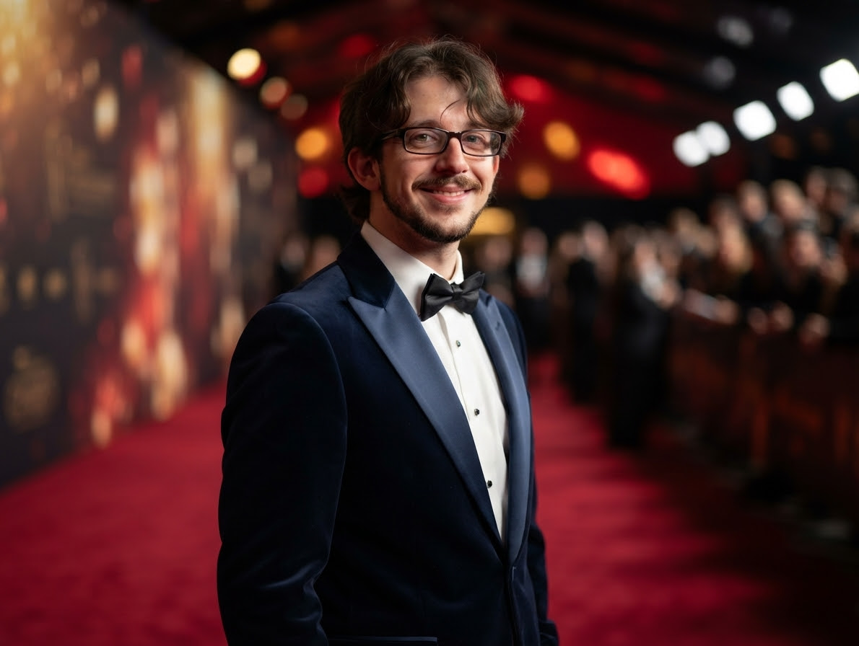

The Pitch
A born entertainer who lives for the spotlight. Nothing on this earth brings Dillon more joy than a packed lounge, a warm follow-spot, and an open mic — he simply adores singing for a crowd and will seize any excuse to perform. Pair that boundless love of the stage with years of close-up magic and you have a headliner who never wants the night to end.

Vocal Range & Passion for Song
- Soaring tenor to velvet baritone — and thrilled to demonstrate at any hour.
- Takes requests eagerly. Encores are not requested; they are inevitable.
- Would genuinely rather be singing right now than reading this résumé.
- Available for spontaneous ballads, show tunes, sea shanties, and karaoke duets.

Signature Act
- Close-up magic & sleight of hand — years of dabbling, finally weaponized for the high seas.
- "The Vanishing Volunteer" — a card trick, a story, and a table of strangers who forget they were skeptical.
- Crowd work — hecklers handled with the same calm as a room of 13-year-olds (see below).
- A song between every trick, because why stop performing?

Stage-Adjacent Experience

Headliner, 3rd Period — Substitute & Student Teacher, Ocean Springs area
2023 – Present
- Performs daily for the single toughest crowd in show business — restless middle schoolers — and keeps them rapt through pure storytelling, including the beloved origin of the word "boycott."
- Held a full house of ~25 for a complete set; a visiting critic (his college supervisor) reviewed the act: "didn't see a student — she saw a teacher."
- Requested back by name by half a dozen bookers (teachers) across multiple venues (schools). Encores demanded regularly.

The Graveyard Residency — Boomtown Casino Biloxi
2014 – 2023
- Nearly a decade working a casino floor overnight — knows the room, the hours, and the after-midnight crowd.
- Improvised genuine crisis stagecraft when the ceiling collapsed mid-shift: roped off the scene, deployed tarps, kept everyone calm. The show, as ever, went on.

The Headset Years — Afni (Verizon)
2011 – 2013
- Hours on the mic daily. Smooth patter, quick recovery, and an uncanny knack for finding the one detail everyone else missed — essentially cold reading with a billing statement.

Quick-Change Artist — Dollar Tree
2024
- Played two management roles at once after his co-star exited stage left. Range.

Credentials
- Mississippi Class A Educator License — officially licensed to captivate teenagers, the most skeptical audience afloat or ashore.
- B.S., History & Social Studies — University of Southern Mississippi, 2023 (a bottomless well of between-song banter).
- A.A., General Studies — Mississippi Gulf Coast Community College, 2021 (GPA 3.49).
- Certified in staying calm when the literal ceiling falls.

Technical & Hospitality Rider
- One (1) enthusiastic audience, one (1) microphone, and one (1) small table for close-up work.
- A deck of cards. He brings his own; do not offer him yours (he'll know).
- Please do not discourage the singing. He will sing. It is happening.
- Reasonable notice before any volunteer is sawed in half (volunteer may reappear, mid-song).

